<!DOCTYPE html>

<html lang="en">

<head>

    <meta charset="utf-8">

    <title>Academic and Living Resource Feedback</title>

    <meta name="viewport" content="width=device-width, initial-scale=1.0">

    <meta name="description" content="Providing support and resources for academic and living needs.">

    <meta name="keywords" content="academic help, living resources, feedback, community support">

    <!-- Favicon -->

    <link href="img/favicon.ico" rel="icon">

    <!-- Google Web Fonts -->

    <link rel="preconnect" href="https://fonts.gstatic.com">

    <link href="https://fonts.googleapis.com/css2?family=Jost:wght@500;600;700&family=Open+Sans:wght@400;600&display=swap" rel="stylesheet">

    <!-- Icon Font Stylesheet -->

    <link href="https://cdnjs.cloudflare.com/ajax/libs/font-awesome/5.10.0/css/all.min.css" rel="stylesheet">

    <link href="https://cdn.jsdelivr.net/npm/bootstrap-icons@1.4.1/font/bootstrap-icons.css" rel="stylesheet">

    <!-- Libraries Stylesheet -->

    <link href="lib/owlcarousel/assets/owl.carousel.min.css" rel="stylesheet">

    <link href="lib/animate/animate.min.css" rel="stylesheet">

    <link href="lib/tempusdominus/css/tempusdominus-bootstrap-4.min.css" rel="stylesheet">

    <link href="lib/twentytwenty/twentytwenty.css" rel="stylesheet">

    <!-- Customized Bootstrap Stylesheet -->

    <link href="css/bootstrap.min.css" rel="stylesheet">

    <!-- Template Stylesheet -->

    <link href="css/style.css" rel="stylesheet">

</head>

<body>

    <!-- Spinner Start -->

    <div id="spinner" class="show bg-white position-fixed translate-middle w-100 vh-100 top-50 start-50 d-flex align-items-center justify-content-center">

        <div class="spinner-grow text-primary m-1" role="status">

            <span class="sr-only">Loading...</span>

        </div>

        <div class="spinner-grow text-dark m-1" role="status">

            <span class="sr-only">Loading...</span>

        </div>

        <div class="spinner-grow text-secondary m-1" role="status">

            <span class="sr-only">Loading...</span>

        </div>

    </div>

    <!-- Spinner End -->

    <!-- Topbar Start -->

    <div class="container-fluid bg-light ps-5 pe-0 d-none d-lg-block">

        <div class="row gx-0">

            <div class="col-md-6 text-center text-lg-start mb-2 mb-lg-0">

                <div class="d-inline-flex align-items-center">

                    <small class="py-2"><i class="far fa-clock text-primary me-2"></i>Review, Recommend and Connect</small>

                </div>

            </div>

            <div class="col-md-6 text-center text-lg-end">

                <div class="position-relative d-inline-flex align-items-center bg-primary text-white top-shape px-5">

                    <div class="me-3 pe-3 border-end py-2">

                        <p class="m-0"><i class="fa fa-envelope-open me-2"></i><a href="mailto:sample@gmail.com" class="text-white">sample@gmail.com</a></p>

                    </div>

                    <div class="py-2">

                        <p class="m-0"><i class="fa fa-phone-alt me-2"></i><a href="tel:+123456789" class="text-white">+123456789</a></p>

                    </div>

                </div>

            </div>

        </div>

    </div>

    <!-- Topbar End -->

    <!-- Navbar Start -->

    <nav class="navbar navbar-expand-lg bg-white navbar-light shadow-sm px-5 py-3 py-lg-0">

        <a href="index.php" class="navbar-brand p-0">

            <h1 class="m-0 text-primary"><i class="bi bi-square"></i>Academic and Living Resource Feedback Network</h1>

        </a>

        <button class="navbar-toggler" type="button" data-bs-toggle="collapse" data-bs-target="#navbarCollapse">

            <span class="navbar-toggler-icon"></span>

        </button>

        <div class="collapse navbar-collapse" id="navbarCollapse">

            <div class="navbar-nav ms-auto py-0">

                <a href="index.php" class="nav-item nav-link active">Home</a>

                <a href="about.php" class="nav-item nav-link">About</a>

                <div class="nav-item dropdown">

                    <a href="#" class="nav-link dropdown-toggle" data-bs-toggle="dropdown">Services</a>

                    <div class="dropdown-menu m-0">

                        <a href="academic.php" class="dropdown-item">Academic Help</a>

                        <a href="food.php" class="dropdown-item">Food Help</a>

                        <a href="living.php" class="dropdown-item">Living Help</a>

                        <a href="counselling.php" class="dropdown-item">Counseling Help</a>

                        <a href="network.php" class="dropdown-item">Network Help</a>

                    </div>

                </div>

                <div class="nav-item dropdown">

                    <a href="#" class="nav-link dropdown-toggle" data-bs-toggle="dropdown">Details</a>

                    <div class="dropdown-menu m-0">

                        <a href="pricing.php" class="dropdown-item">Pricing Plan</a>

                        <a href="team.php" class="dropdown-item">Team</a>

                        <a href="testimonial.php" class="dropdown-item">Testimonials</a>

                        <a href="offer.php" class="dropdown-item">Offers</a>

                    </div>

                </div>

                <a href="connect.php" class="nav-item nav-link">Connect</a>

            </div>

        </div>

    </nav>

    <!-- Navbar End -->

    <!-- Full Screen Search Start -->

    <div class="modal fade" id="searchModal" tabindex="-1">

        <div class="modal-dialog modal-fullscreen">

            <div class="modal-content" style="background: rgba(9, 30, 62, .7);">

                <div class="modal-header border-0">

                    <button type="button" class="btn bg-white btn-close" data-bs-dismiss="modal" aria-label="Close"></button>

                </div>

                <div class="modal-body d-flex align-items-center justify-content-center">

                    <div class="input-group" style="max-width: 600px;">

                        <input type="text" class="form-control bg-transparent border-primary p-3" placeholder="Type search keyword">

                        <button class="btn btn-primary px-4"><i class="bi bi-search"></i></button>

                    </div>

                </div>

            </div>

        </div>

    </div>

    <!-- Full Screen Search End -->

    <!-- Carousel Start -->

    <div class="container-fluid p-0">

        <div id="header-carousel" class="carousel slide carousel-fade" data-bs-ride="carousel">

            <div class="carousel-inner">

                <div class="carousel-item active">

                    <img class="w-100" src="img/carousel-1.jpg" alt="Support for easy living">

                    <div class="carousel-caption d-flex flex-column align-items-center justify-content-center">

                        <div class="p-3" style="max-width: 900px;">

                            <h5 class="text-white text-uppercase mb-3 animated slideInDown">Take Care of Yourself</h5>

                            <h1 class="display-1 text-white mb-md-4 animated zoomIn">Provides Full Support for Easy Living</h1>

                            <a href="login.php" class="btn btn-primary py-md-3 px-md-5 me-3 animated slideInLeft">Login</a>

                            <a href="connect.php" class="btn btn-secondary py-md-3 px-md-5 animated slideInRight">Contact Us</a>

                        </div>

                    </div>

                </div>

                <div class="carousel-item">

                    <img class="w-100" src="img/carousel-2.jpg" alt="Support for easy living">

                    <div class="carousel-caption d-flex flex-column align-items-center justify-content-center">

                        <div class="p-3" style="max-width: 900px;">

                            <h5 class="text-white text-uppercase mb-3 animated slideInDown">Take Care of Yourself</h5>

                            <h1 class="display-1 text-white mb-md-4 animated zoomIn">Provides Full Support for Easy Living</h1>

                            <a href="login.php" class="btn btn-primary py-md-3 px-md-5 me-3 animated slideInLeft">Login</a>

                            <a href="connect.php" class="btn btn-secondary py-md-3 px-md-5 animated slideInRight">Contact Us</a>

                        </div>

                    </div>

                </div>

            </div>

            <button class="carousel-control-prev" type="button" data-bs-target="#header-carousel" data-bs-slide="prev">

                <span class="carousel-control-prev-icon" aria-hidden="true"></span>

                <span class="visually-hidden">Previous</span>

            </button>

            <button class="carousel-control-next" type="button" data-bs-target="#header-carousel" data-bs-slide="next">

                <span class="carousel-control-next-icon" aria-hidden="true"></span>

                <span class="visually-hidden">Next</span>

            </button>

        </div>

    </div>

    <!-- Carousel End -->

    <!-- Main Content Here -->

    <!-- Footer Start -->

    <footer class="container-fluid bg-light text-dark mt-5 pt-5">

        <div class="container text-center">

            <div class="row">

                <div class="col-lg-4 col-md-6 mb-4">

                    <h5>About Us</h5>

                    <p>We provide a comprehensive range of resources and support for academic and living needs.</p>

                </div>

                <div class="col-lg-4 col-md-6 mb-4">

                    <h5>Contact</h5>

                    <p>Email: <a href="mailto:sample@gmail.com">sample@gmail.com</a></p>

                    <p>Phone: <a href="tel:+123456789">+123456789</a></p>

                </div>

                <div class="col-lg-4 col-md-6 mb-4">

                    <h5>Follow Us</h5>

                    <a href="#" class="btn btn-primary btn-sm">Facebook</a>

                    <a href="#" class="btn btn-primary btn-sm">Twitter</a>

                    <a href="#" class="btn btn-primary btn-sm">LinkedIn</a>

                </div>

            </div>

        </div>

    </footer>

    <!-- Footer End -->

    <!-- Back to Top -->

    <a href="#" class="btn btn-primary btn-lg back-to-top"><i class="bi bi-arrow-up"></i></a>

    <!-- JavaScript Libraries -->

    <script src="https://code.jquery.com/jquery-3.6.0.min.js"></script>

    <script src="https://cdn.jsdelivr.net/npm/bootstrap@5.1.3/dist/js/bootstrap.bundle.min.js"></script>

    <script src="lib/owlcarousel/owl.carousel.min.js"></script>

    <script src="lib/animate/wow.min.js"></script>

    <script src="lib/tempusdominus/js/moment.min.js"></script>

    <script src="lib/tempusdominus/js/tempusdominus-bootstrap-4.min.js"></script>

    <script src="lib/twentytwenty/jquery.event.move.js"></script>

    <script src="lib/twentytwenty/jquery.twentytwenty.js"></script>

    <!-- Template Javascript -->

    <script src="js/main.js" defer></script>

</body>

</html>

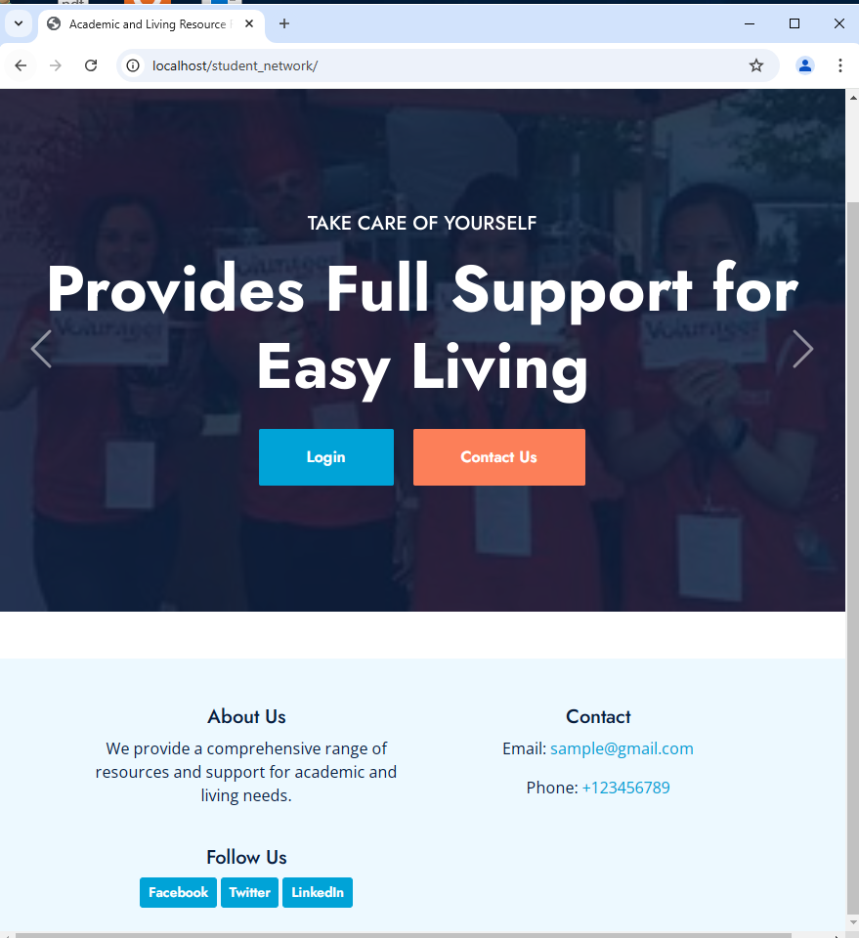

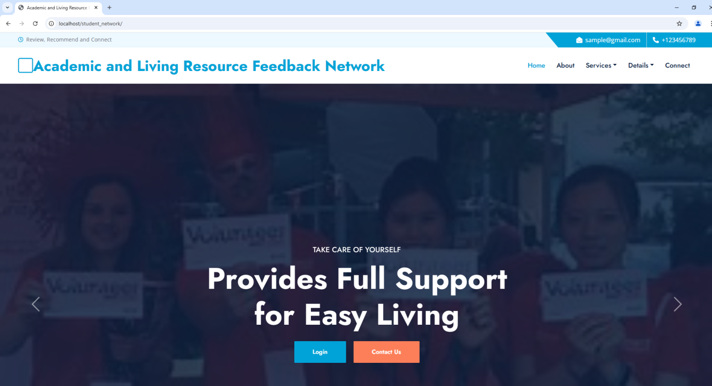

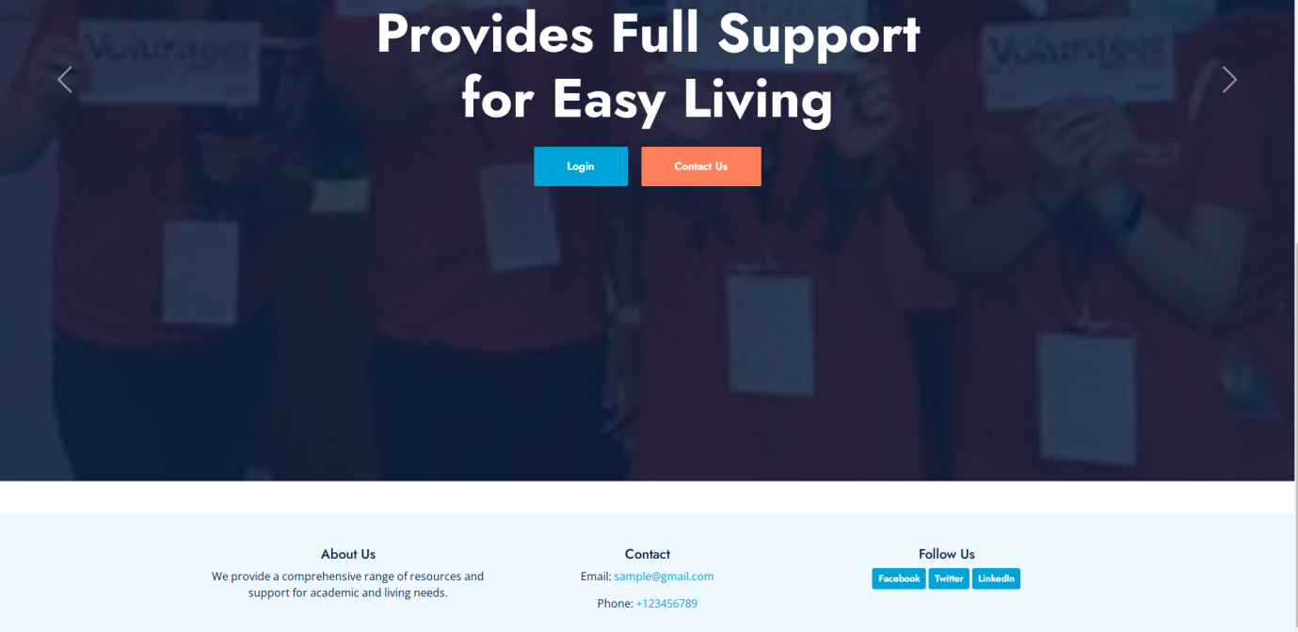

<?php

// Database connection setup

$servername = "localhost"; // Your server (usually localhost)

$username = "root"; // Default MySQL username

$password = ""; // Default MySQL password (empty for XAMPP, WAMP, MAMP)

$dbname = "student"; // Database name

// Create connection

try {

    $pdo = new PDO("mysql:host=$servername;dbname=$dbname", $username, $password);

    // Set the PDO error mode to exception

    $pdo->setAttribute(PDO::ATTR_ERRMODE, PDO::ERRMODE_EXCEPTION);

} catch(PDOException $e) {

    echo "Connection failed: " . $e->getMessage();

    exit();

}

// Handle registration form submission

if (isset($_POST['register'])) {

    $email = $_POST['regEmail'];

    $password = $_POST['regPassword'];

    $confirmPassword = $_POST['regConfirmPassword'];

    // Validate form inputs

    if (empty($email) || empty($password) || empty($confirmPassword)) {

        $error = "All fields are required.";

    } elseif ($password !== $confirmPassword) {

        $error = "Passwords do not match.";

    } else {

        // Hash the password for security

        $hashedPassword = password_hash($password, PASSWORD_DEFAULT);

        // Check if the email is already registered

        $stmt = $pdo->prepare("SELECT id FROM users WHERE email = :email");

        $stmt->execute(['email' => $email]);

        if ($stmt->fetch()) {

            $error = "Email is already registered.";

        } else {

            // Insert new user into the database

            $stmt = $pdo->prepare("INSERT INTO users (email, password) VALUES (:email, :password)");

            if ($stmt->execute(['email' => $email, 'password' => $hashedPassword])) {

                $success = "Registration successful! Please login.";

            } else {

                $error = "Error occurred during registration.";

            }

        }

    }

}

// Handle login form submission

if (isset($_POST['login'])) {

    $email = $_POST['email'];

    $password = $_POST['password'];

    // Validate form inputs

    if (empty($email) || empty($password)) {

        $error = "Email and password are required.";

    } else {

        // Fetch user from the database

        $stmt = $pdo->prepare("SELECT id, password FROM users WHERE email = :email");

        $stmt->execute(['email' => $email]);

        $user = $stmt->fetch();

        // Verify password

        if ($user && password_verify($password, $user['password'])) {

            // Start session and redirect to the dashboard

            session_start();

            $_SESSION['user_id'] = $user['id'];

            $_SESSION['email'] = $email;

            header("Location: dashboard.php"); // Create this file as the dashboard

            exit();

        } else {

            $error = "Invalid email or password.";

        }

    }

}

?>

<!DOCTYPE html>

<html lang="en">

<head>

    <meta charset="UTF-8">

    <meta name="viewport" content="width=device-width, initial-scale=1.0">

    <title>Login & Registration - Academic and Living Resource Feedback</title>

    <link href="css/bootstrap.min.css" rel="stylesheet">

    <link href="css/style.css" rel="stylesheet">

</head>

<body>

    <!-- Navbar Start -->

    <nav class="navbar navbar-expand-lg bg-white navbar-light shadow-sm px-5 py-3 py-lg-0">

        <a href="index.php" class="navbar-brand p-0">

            <h1 class="m-0 text-primary"><i class="bi bi-square"></i> Academic and Living Resource Feedback Network</h1>

        </a>

    </nav>

    <!-- Navbar End -->

    <!-- Main Section Start -->

    <div class="container mt-5">

        <h2 class="text-center">Login & Register</h2>

        <div class="row justify-content-center">

            <div class="col-lg-4 col-md-6">

                <!-- Display success or error messages -->

                <?php if (isset($error)): ?>

                    <div class="alert alert-danger"><?= $error ?></div>

                <?php elseif (isset($success)): ?>

                    <div class="alert alert-success"><?= $success ?></div>

                <?php endif; ?>

                <!-- Login Form Start -->

                <h4>Login</h4>

                <form method="POST">

                    <div class="mb-3">

                        <label for="email" class="form-label">Email address</label>

                        <input type="email" class="form-control" id="email" name="email" placeholder="Enter your email" required>

                    </div>

                    <div class="mb-3">

                        <label for="password" class="form-label">Password</label>

                        <input type="password" class="form-control" id="password" name="password" placeholder="Enter your password" required>

                    </div>

                    <div class="d-flex justify-content-between">

                        <div>

                            <input type="checkbox" id="rememberMe">

                            <label for="rememberMe">Remember me</label>

                        </div>

                        <a href="#">Forgot Password?</a>

                    </div>

                    <button type="submit" name="login" class="btn btn-primary w-100 mt-3">Login</button>

                </form>

                <!-- Registration Link -->

                <p class="text-center mt-3">Don't have an account? <a href="#" data-bs-toggle="collapse" data-bs-target="#registerForm">Register here</a></p>

                <!-- Register Form Start -->

                <div id="registerForm" class="collapse mt-3">

                    <h4>Register</h4>

                    <form method="POST">

                        <div class="mb-3">

                            <label for="regEmail" class="form-label">Email address</label>

                            <input type="email" class="form-control" id="regEmail" name="regEmail" placeholder="Enter your email" required>

                        </div>

                        <div class="mb-3">

                            <label for="regPassword" class="form-label">Password</label>

                            <input type="password" class="form-control" id="regPassword" name="regPassword" placeholder="Enter your password" required>

                        </div>

                        <div class="mb-3">

                            <label for="regConfirmPassword" class="form-label">Confirm Password</label>

                            <input type="password" class="form-control" id="regConfirmPassword" name="regConfirmPassword" placeholder="Confirm your password" required>

                        </div>

                        <button type="submit" name="register" class="btn btn-primary w-100">Register</button>

                    </form>

                </div>

                <!-- Register Form End -->

            </div>

        </div>

    </div>

    <!-- Main Section End -->

    <!-- Footer Start -->

    <footer class="container-fluid bg-light text-dark mt-5 pt-5">

        <div class="container text-center">

            <p>&copy; 2024 Academic and Living Resource Feedback Network. All rights reserved.</p>

        </div>

    </footer>

    <!-- Footer End -->

    <script src="https://code.jquery.com/jquery-3.6.0.min.js"></script>

    <script src="https://cdn.jsdelivr.net/npm/bootstrap@5.1.3/dist/js/bootstrap.bundle.min.js"></script>

</body>

</html>

